Chapter 9, Problem 40.

In the circuit of Fig. 9.47, find i_{o}(t) when:

- ω = 1 rad/s
- ω = 5 rad/s
- ω = 10 rad/s
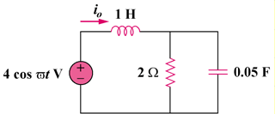

Figure 9.47
For Prob. 9.40.

